**Former Felons and the Decline in U.S. Labor Force Participation, 1980-2010**

Ryan Larson, Sarah Shannon, Aaron Sojourner & Chris Uggen

-in introduction: what are our contributions?

Nationally rep data, looking at aggregate link, no study has done before - X

Intersection between two critically important phenomenon - X

-lit review: identifying state of knowledge, *position our paper relative to existing work

-little more to motivate around the population level, aggregate level trends

-lit review: social threat effects of incarceration (Jacobs and Helms, etc.)

-our measure of felony status is the proximal and salient to employers, more so than incarceration **\*2ND CONTRIBUTION** (what do employers ask? Vuolo and lageson, crim and public policy)

-make explicit the different populations (incarcerated vs. non-incarcerated) and why its important to use our population (signal conviction history as opposed to incarceration history)

-explicitly call out disability as an alternative explanation, also cite Larry Summers (aaron email)

-Clean up tables: var names, DV in all titles

-lead with employment puzzle, add in criminal stigma as explanation

-Chiricos et. al 2007 foreshadow to motivate why we’d look at subgroups (heterogeneous effects **\*3rd contribution)** For whom does the effect matter?

-motivate the time period. Why this set of years.

-not employed rate is the complement to the employment to population ratio. Focus on this as opposed to LFPR - x

-create models of unemployment rate and idleness rate as robustness checks

-discuss more about why we’re choosing the economic measure we’re using.

-make map the changes from 1988-2010, make a map with changes in NES as well, discuss these -x

-add spaghetti plot - x

**Abstract**

As the rate of people with felony-level criminal records rose during the mass incarceration era, labor force participation rates have declined. Criminological theories of labeling and stigmatization, as well as economic theories of statistical discrimination, suggest causal linkages between the two phenomena. Over this period, surveys of employers have shown increasing reliance on criminal background checks and audit studies showed high rates of discrimination against people with felony-level criminal records. This paper uses novel, state-level measures of individuals with felony-level records and estimates pooled cross-sectional time series models to examine whether and how changes in the rate of people subject to such records has affected their participation in the labor force. In models for prime-age workers (those age 25-54), we find that a 10 percentage-point increase in the rate of ex-felons is associated with 2 percentage point increase in the rate of non-employment (those unemployed or not in the labor force). However, these results are sensitive to subgroup analyses: effects are stronger for both women and whites. These results suggest the stigma of a felony record likely plays an important part in aggregate employment rates as well as in individual hiring practices.

**Introduction**

The mass incarceration and probation era of U.S. punishment has resulted in a proliferation of criminal labels applied to its citizenry. In 2010, approximately 19 million individuals were marked by a felony criminal record, of which 14.47 million are no longer under any form of correctional supervision (Shannon et. al. 2017). A robust literature on the collateral consequences – consequences above and beyond the adjudicated sentence – suggests that the proliferation of criminal records has increased the exposure of individuals to various barriers in employment, housing, voting, and other areas of social life (Uggen and Stewart 2015). A focal consequence of the research literature has been employment, and observational and experimental audit research (e.g., Apel and Sweeten 2010; Pager 2003) have demonstrated robust effects of criminal records on employment outcomes.

Concurrently to the increases in U.S. punishment and production of criminal records, the national labor force participation rate (LFPR) has declined by 3.3 percentage points, since at peak of 67.3% in 2000 (Aaronson et.al. 2012). Economic scholarship has examined the decrease in LFPR, attributing its decline largely to shifting demographics and the economic recession (e.g., Aaronson et. al. 2012). Taken together, these trends suggest that the increases in punishment nationally – and the subsequent proliferation of criminal records – could have had a role in the decline of labor force participation nationally. In other words, do the expanding employment consequences of a criminal record “move the needle” of national labor force participation?

This paper leverages new state-level estimates of people formerly incarcerated and people formerly under correction supervision to estimate the relationship between state-level criminal record density and aggregate employment metrics. These criminal record estimates originate from recent effort to estimate and examine the distribution of felony criminal records in the U.S. using demographical life table methods (Shannon et. al. 2017). Although the U.S. Department of Justice provides information on those currently under correctional supervision, these estimates represent the first state-level estimates of former prison or felony supervision populations. We also exploit state and time variation in a generalized differences-in-differences design to help identify the causal impact of state-level criminal records on labor force participation. In doing so, we present the first estimates of aggregate level criminal records and labor force participation, which is critical to the evaluating the aggregate sociological and economic consequences of the criminal justice system in the U.S.

In the paragraphs that follow, we first discuss the trends in both punishment and criminal records, as well as labor force participation. We then review the theoretical and empirical literature on the labor market consequences of a criminal record. Following a description of the data, statistical methodology, and empirical results, an extended discussion of the study’s implications for further research and public policy are explicated.

**Mass Punishment and the Rise of Criminal Records**

The United States criminal justice system has grown dramatically over the past forty years. The imprisonment rate – the number of individuals in prisons per 100,000 adult population– was 161 in 1972, and peaked in 2007 at 670, and has decreased modestly to 593 at year end 2015 (Carson and Anderson 2016). This compares with a world average of 144 per 100,000 (Walmsley 2015), which marks the United States as an outlier in terms of incarceration internationally. About 1 in 53 US adults is under community supervision – probation or parole (Kaeble and Bonczar 2016) – which represents a far larger correction population pool than those incarcerated, with the probation to incarceration ratio per 10 index crimes at 2.7 in 2010 (Phelps 2013). This rise in punishment has not been proportional along racial lines. Police contact is higher for racial and ethnic groups, net of previous arrest rates (Gelman et al. 2007), and almost half of all black men will be arrested prior to the age of 23 (Brame et al. 2012; Brame et al. 2014). Similar patterns are found among more serious forms of criminal justice contact: the risk of imprisonment is 1 in 5 for Black men, as compared to 1 in 30 for white men (Western and Wildeman 2009), which makes incarceration a more common life event than earning a college degree or entering the military for Black men (Pettit and Western 2004). This relative disparity in imprisonment was 6.8 in 1990 and 4.6 in 2010, indicating that although the relative incarceration disparity had declined towards the end of the mass incarceration era, it is still quite large (National Academy of Sciences 2014). Thus, the “mass incarceration” era of criminal punishment has not been evenly distributed across the national population.

This era of both mass incarceration and mass probation has led to the proliferation of felony criminal records among the U.S. population. Shannon et. al. (2017) estimate that over 19 million individuals have felony criminal convictions but are no longer under correctional supervision, which translates to about 8.1% of the overall adult population and 23.4% of African American adults. The subpopulation of those with prison experience among those convicted with a felony is about 7.3 million, of which about 4.9 million have served their time on prison and/or parole. Additionally, substantial between-state variation exists in the number of individuals with felony criminal records (Shannon et. al. 2017).

**Trends in Labor Force Participation**

The aggregate civilian LFPR (those aged 16 and above) in the United States rose steadily in the mid-1960s, and continued to expand into the 1990s. Research attributes this rise in labor force participation to the entrance of women into the labor force, the entry of the baby boom cohort into the prime-age working years in the 1970s and 1980s, improvements in health technology, and the shift away from manual labor occupations (Aaronson et. al. 2012). Since the early 2000s,the civilian LFPR has declined. The LFPR peaked in the year 2000 at a rate of 67.3%, and declined by 3.3 percentage points to 64.0% in 2011 (Aaronson et. al. 2011). Since 2011, the LFPR continued to decline until November 2015, where it has remained relatively stable since. As of November 2018, the national LFPR was 62.9%, comparable to levels of participation observed in the late 1970s (Bureau of Labor Statistics 2018).

The prime-age LFPR (those aged 25-54) follows a similar increase but peaks earlier (February 1999 – 84.4%), and exhibits an attenuated decline as compared to the civilian LFPR. The prime-age LFPR decline descends modestly to 80.6% in September of 2015, then increases slightly to 82.2% in November of 2018, albeit not returning to its late 1990s peak. This suggests that at least part of the decline in overall labor force participation is concentrated among those 18-25 and 55 and above.

Economic research has attributed this drop to both the recession – and its lackluster recovery – and demographic trends (Aaronson et. al. 2015, Aaronson et. al. 2014). In 1996, the first baby boomer cohort turned 50, which generally represents a peak in participation. Additionally, there has been a downward trend in teen work activity, which started to accelerate in the later 2000s in response to increased youth involvement in educational activities, as well as immigration and occupational polarization (Smith 2011). Aside from these structural influences, cyclical weakness in the business cycle also depresses the participation rate (Aaronson et. al. 2014). Further work stresses other demand side factors such as trade and the introduction of automation into the labor market, and illustrates that supply side factors, such as enrollment in disability insurance programs play a smaller role (Abraham and Kearney 2018). The current study brings in criminal records as a complementary explanatory factor in the variation in the not-employed rate.

**Punishment, Records, and Employment**

Two primary theoretical perspectives suggest that criminal records and imprisonment would have detrimental impacts on employment prospects. The stigma or market signal perspective suggests that the mark of criminal record serves as a tangible signal to employer – who are making hiring decisions with incomplete information – about “what kind of employee is likely to be (Apel and Sweeten 2010, p. 451)”, and in this way resembles what economists would call statistical discrimination (Arrow 1978). Beyond just employer fears of “employee crime”, a criminal record may spur employer assumptions of productivity, trustworthiness, social skills, etc. that are stereotypically associated with criminal behavior. In this form, the criminal record is a form of discrediting social stigma (Goffman 1963) which can serve as a form of institutional exclusion to the labor force and can create further social disadvantages that accumulate over time (Becker 1963; Sampson and Laub 1997). A related theoretical tenet in the stigma literature is that of identity transformation, which is rooting in the sociological tradition of symbolic interaction. In this line of thought, labeled individuals may adopt a criminal self-concept and take on the roles, attitudes, and behaviors perceived to be packaged as a part of that identity (Jensen 1972; Lemert 1951). Labeled individuals may place less value of legitimate employment and other societal conventions, and withdraw from the normative institution of work. Therefore, in addition to structural exclusion, the labeling process may also transform individual identities and behaviors that impact interaction with the labor market.

A second theoretical strain claims that contact with the criminal justice system can decrease human capital and create experience gaps, as well as undermine health social relationships, all of which employment and wages are theorized to be endogenous to. Although this theoretical stance is primarily concerned with the impacts of incarceration, these effects are wrapped up in with the impacts of stigma when one considers the effect of the entire record. Punishment may result in a “time out” from the labor market which can translate into a erosion of skills and experience important for employment (Western, Kling, and Weiman 2001). The conditions of punishment may also directly affect both physical and mental health. Incarceration and the experience of punishment can be a stressful life event, and formerly incarcerated individuals are likely to encounter more stressors after release such as stigma and discrimination and finding housing, which in turn exposes one to illnesses associated with stress (Massoglia 2008). Finally, the incarceration and/or the label of a criminal label can impact the formation and stability of social networks and the resources associated with social ties. Incarceration, or stigma from a record, can distance one from key social ties that can assist in job search (Berg and Huebner 2010).

A wealth of studies have examined the labor market consequences of criminal justice events and outcomes (e.g., arrest) on various employment related outcomes, which arguably represents the largest collateral consequence literature base. A large portion of the observational evidence concerns the impact of incarceration on subsequent employment. The majority of these observational studies use administrative data sources (Waldfogel 1994; Grogger 1995; Kling 2006; Pettit and Lyons 2007; Sabol 2007; Lalonde and Cho 2008; Loeffler 2013) or survey data such as the National Longitudinal Survey of Youth 1979 (NSLY79) (Freeman 1992; Western 2002, 2006; Raphael 2007; Apel and Sweeten 2010). In general, the survey-based studies find that incarceration is negatively associated with employment, with a reduction by about 10%-20% after incarceration. Some studies also focus on the impacts of incarceration on wages and wage growth. For example, Western (2002) finds that imprisonment is associated with depressed wages – about 16% less than those not incarcerated- and also highlights the stagnated wage growth among those with an incarceration history.

The results from the administrative datasets is less consistent, with both negative and null findings, and effect magnitudes that are smaller than the survey-based studies (about 5% reduction in employment likelihood). Harding et. al. (2018) speculate that the discrepancy in results could be the result of differences in the “control group” as administrative datasets compare convicted groups (e.g., prison vs. parole), whereas the survey studies compare those incarcerated to a more general population. Further, the administrative studies generally find that incarceration increases employment in the short-term following release, particularly among those with a limited presentence work history, which erodes over time (e.g., Harding et. al. 2018). However, these studies specifically focus on incarceration, which encapsulates the experience of only a portion of those subject to a felony conviction.

Another strain of scholarship uses experimental audit methodologies to examine the impact of a criminal record on employment outcomes. This research experimentally manipulates the signal of a criminal record on job applications and resumes, which measure the “credentialing” effect of punishment on employment prospects. Pager (2003), using a field audit methodology, sent testers to in-person job applications in Milwaukee and experimentally manipulated the race and criminal record of the applicant. She finds that, among white applicants, the presence of a criminal record decreased the likelihood of a callback by 50% as compared to the non-record control. Further, Pager (2003) also finds an effect of race, with the Black nonoffenders less likely to receive a job callback than the white nonoffenders. Race also interacts with the record, with the criminal record penalty for Blacks being 40% larger than that of whites.

In a follow-up study in New York City, Pager et al. (2009) used two teams of a white, Black, and Latino testers and found that whites received more callbacks than either Latino or Black testers, and Latinos were preferred over Black applicants. However, when comparing Black and Latino testers to a white applicant with a criminal record, they found no statistically significant differences in callback rates indicating that “while ex-offenders are disadvantaged in the labor market relative to applicants with no criminal background, the stigma of a felony conviction appears to be no greater than that of minority status (p. 10).” While Pager (2003) and Pager et al. (2009) signaled a criminal record with a drug possession felony, Uggen et al. (2014) examine the lower “the edge of stigma” and signal a disorderly conduct arrest that did not lead to a conviction. They find roughly a four-percentage point difference (about 30% less likely) between the treatment conditions for both white and black testers, and find a statistically significant effect of misdemeanor arrest on callback rates once adjusting for contact with the hiring authority, which increases the likelihood of a callback.

In summary a large body of theoretical and empirical scholarship suggests that, at the aggregate-level, the proliferation of criminal records has the potential to depress labor force participation. A pair of studies (Schmitt and Warner 2013; Abraham and Kearney 2018) estimate that the incarceration rate reduced the employment-to-population-ratio from between .13-1.5 percentage points. Although they do not directly model this effect (each estimate is derived from estimates of the number of people with incarceration histories and a presumed effect size), it provides a baseline by which to compare our estimates of the effect of criminal records (in which incarceration is incorporated). We now turn to the data and design of the current study, which utilizes full state-level estimates of the population of individuals with criminal records and model its impact on the not-employed-rate.

**Data and Design**

We focus on the national population of civilian, non-institutionalized, 18-43 year old adults sampled in the Current Population Survey (CPS) from 1980 to 2010. Importantly, this excludes incarcerated individuals, who are also excluded from our key predictor variable (see below). Our outcome variable in this analysis is the age 18-54 [1]not-employed-rate in each state and year. We conduct our analysis at the state-year level in the 50 states across these 31 years, yielding 1550 observations. However, the CPS started tracking disability in 1988, and in combination with a year reduction for the calculation of lagged variable reduces, via listwise deletion, our primary analyses sample size to 1,150. However, we present alternative specifications of disability in Table 4, where we impute a constant in the period from 1980-1987.[2]

Our focal predictor of interest is the share of the state-year adult (18+) population lining in the community with a felony record no longer under felony supervision. This variable excludes those currently under correctional supervision. These felony record estimates for each state-year are provided by Shannon et. al. (2017), who used demographic life-table models to obtain point estimates of the population in each state who have a felony record. More specifically, each cohort of prison releases and felony probation entries from 1948-2010 are adjusted each subsequent year for mortality, recidivism, mobility, and deportation. Each release cohort is reduced each subsequent year, and summed with each new cohort of releases.[3] These state-level estimates of the population with a felony label offer a more comprehensive view of the reach of the criminal justice system that other estimates, as they encapsulate more than just one stage or event of the criminal justice process (e.g. arrest). The estimates include both those with prison experience (e.g., Pettit 2012), but also those who have not served prison time yet may suffer similar consequences of a felony conviction. On average, about 4.3% of adults have a felony record across these state-years, with a minimum of 1.2% and a max of 12.3% (see Table 1). Additionally, Figure 1 displays the spatial distribution of felony records in 2010. States such as Georgia and Florida stand out with percentages above 10%, and the Northeast U.S. is marked by relatively low percentages of individuals with felony records.

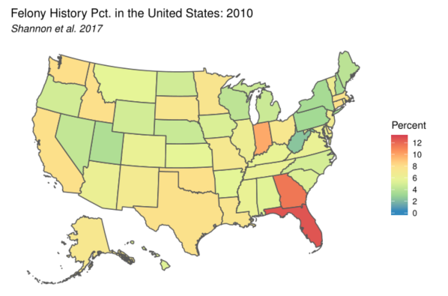

To obtain an estimate for the criminal record population (*β)* we use a generalized differences-in-differences design that relates changes in states’ not-employed-rate (*Yst*) over time to their change in share of adults in the community with a felony record (*Fst*). Conventional difference-in-difference estimates measure a treatment and control group at two different points in time, and compare the difference accounting for the baseline differences in the outcome variable. However, our treatment is applied as a dosage as apposed to a binary indicator, and our data includes multiple time periods. Therefore, we include state fixed effects to capture average, time-stable, unobserved influences on each state’s outcome and year fixed effects to capture average unobserved influences stable across states within each year:

$$Y_{st}= βF_{st}+αX_{st}+γ_{s}+γ_{t}+ε_{st}$$

The identifying assumption is that changes in unobserved influences within state are mean independent of changes in *Fst,* which still leaves our estimate vulnerable to omitted-variables bias. In order to enhance the credibility of this condition more credible, we also condition on various sets of observable, time-varying state-year characteristics (*Xst*) consistent with econometric models of the LFPR (the inverse of the not-employed-rate) (e.g., Aaronson et. al. 2014). Additionally, all models are weighted by the total population in each state-year. We also cluster standard errors by state and year to account for heteroscedasticity, autocorrelation of errors within state, and spatial autocorrelation across states within years.

We condition our estimates on the age distribution in each state-year, as changes in states’ age distributions may drive both changes in the not-employed rate and the felony-history share. To control for changes in the age distribution, we use the CPS to compute state-year population shares for the age 16+ population in the following bins: 16-25, 26-35, 36-45, 46-55, 56-65, and 66+ years old. These shares sum to 100 in each state-year. The percentage of the population with a bachelor’s degree and the marriage rate were also calculated from the CPS, which serve as further demographical controls. Incarceration has been linked to decreases in education (e.g., Bernburg 2003) and is presumably also correlated with labor force participation. Additionally, marriage can influence labor supply choices and a felony history may affect one’s desirability to potential spouses. We also include the overall unemployment rate in each state-year, as well as three lags (t-1, t-2, t-3) to capture cyclical fluctuations in the business cycle. To account for alternative explanations of supply-side dynamics, we include metrics of a state-year’s social welfare net and labor policies. We also include measures of the effective minimum wage (the maximum of the state and federal minimum wage each year), and the mean TANF maximum (the mean of the maximum Assistance to Families with Dependent Children or Temporary Assistance to Needy Families cash benefit available to a 2-person family, a 3-person family, and a 4-person family in each state-year), which come from University of Kentucky’s Center for Poverty Research Welfare Data. Finally, we include a control of unemployment compensation, which is a measure of the maximum weekly unemployment benefit by state-year, which comes from Michigan State University’s Correlates of State Policy dataset. In alternative specifications of disability (see Table 4) we include rates of Social Security Insurance, which provide income to adults who cannot work due to a disability. Descriptive statistics for all the variables included in the primary analyses can be found in Table 1.

After our primary models, we estimate conditional model based upon demographical subgroups within our data. Specifically, we run models for both males and females separately, and for whites and Blacks separately. It should be noted that, where applicable, the CPS variables were aggregated wo reflect the particular grouping filter, but some of the variables (e.g., mean TANF max) are equally applicable among the groups. Additionally, Shannon et. al. (2017) only estimate two state-level estimates: an overall percentage and a Black specific percentage. Therefore, we utilize the Black specific measure of felony-history share in our Black subgroup model, but use the overall rate in each of the other models.

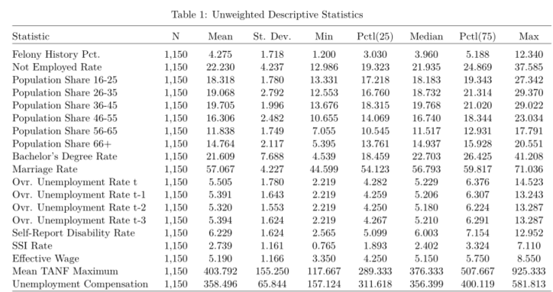

**Results**

Table 2 presents four models of the not-employed-rate among those aged 18-54 with alternative specifications in terms of control variables. Model 1 introduces our focal predictor, felony history percentage, alongside state and year fixed effects. Felony history percentage has a statistically significant positive effect on the not-employed rate, with a one-unit increase (an increase in 1%) associated with approximately .3% increase in the not-employed-rate. Model 2 adds in a block of demographic controls including population age shares, the percentage of the population with a bachelor’s degree, and the marriage rate. Felony history percentage maintains its statistically significant positive effect, and the degree and marriage rates do not have statistically significant independent effects on the not-employed-rate. Model 3 introduces our block of unemployment variables to capture periodic fluctuations in the business cycle, and felony history percentage remains its significant positive effect, albeit slightly attenuated. Finally, our full specifications adds to the model the supply side factors of social welfare and state labor policy. In our full specification, felony history percentage has its largest effect magnitude, with a one-unit increase in felony history corresponding to a .33% increase in the not employed rate.

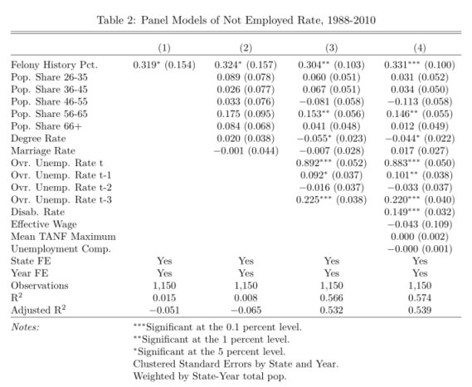

Table 3 presents our alternative subgroup sample models. Model 1 presents estimates for males ages 18-54, and felony history percentage has a nonsignificant, albeit positive, impact on the not-employment-rate. In contrast, Model 2, displays a statistically significant effect almost 5 times larger than that of the male subgroup. We see a similar bifurcation in the race submodels: a statistically significant effect exists for the white subgroup, but not for the Black subgroup. [4]

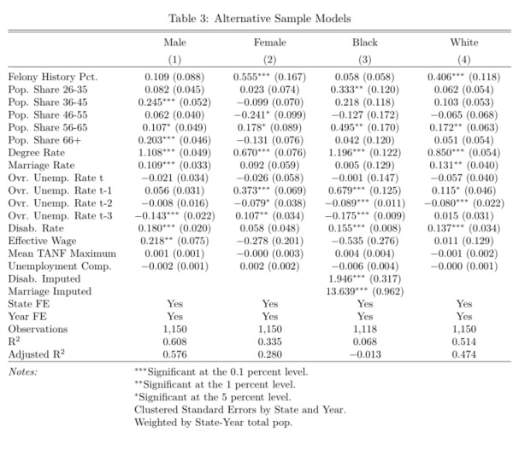

Table 4 explicates alternative specifications of disability as model robustness checks. Model 1 includes the SSI rate, and Model 2 includes the additionally SSI variable alongside imputations of the self-report disability rate in the 1980-1987 series (see footnote 2). Model 3 keeps the imputation but removes SSI from the specification. Across all three alternative models, felony history percentage maintains its statistically significant positive effect with a magnitude just above .3 in all models.

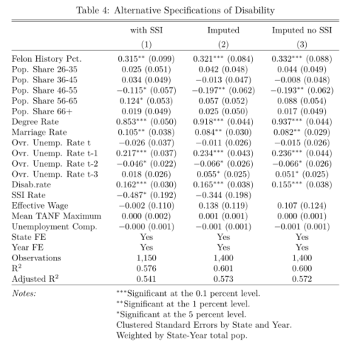

**Discussion**

**References**

**Appendix**

1. We estimated our models with various age filtering parameters, including a prime-age restriction, and results proved robust to multiple age specifications. Models are available upon request to the corresponding author.
2. The insertion of a constant value in this series does not bias our coefficients of interest, as the inclusion of year fixed effects takes out any state-constant variation.
3. See Shannon et. al. 2017 for further detail of the estimation procedure.
4. The Black model includes imputations for both the disability rate and marriage rate, and includes binary predictors indicating missingness was not at random. We drop another 32 cases due to missing data on the dependent variable. The imputations performed were linear interpolations using data from the year before and the year subsequent the missing data point.